We were given two tasks to implement for our LLM Lab-1. In this Lab we mainly focused on implementing the KNN classifier and observing its behavior. We’ll start with a short preview of the first task and then move on to the next.

For the first task we were given a CSV file “data.csv” containing the measurements from a digitized image of a fine needle aspirate (FNA) of a breast mass. We had to divide the 80% data for training and 20% data for testing.

We were given the following Hyperparameters for Experimentation:
● Values of K: 3,4,9,20 and 47.
● Distance Matrix: Euclidean Distance, Manhattan Distance, Minkowski Distance,
Cosine Similarity, Hamming Distance .

We had to build a KNN based classification model from scratch to be trained on a given
dataset and recommend the best value for K (number of neighbors) and
distance matrix that produces the highest accuracy for test data.

These were the Expected Outcomes:
● Pick the best value of K and distance matrix based on the testing accuracy, and
for the best value of K, print confusion matrix, recall, and precision.
● Plot the graph between K values vs Accuracy considering different distance
matrices.
● Inferences on the plots and inferences on the results observed.

Brief Overview of the Procedure

- We first uploaded our dataset and imported the necessary libraries needed to work with our data
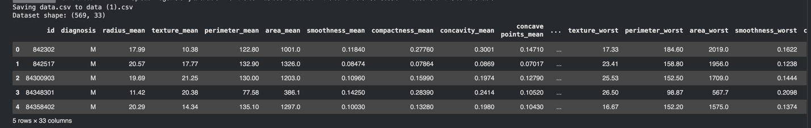
- We observed our sample size, our features and the class distribution
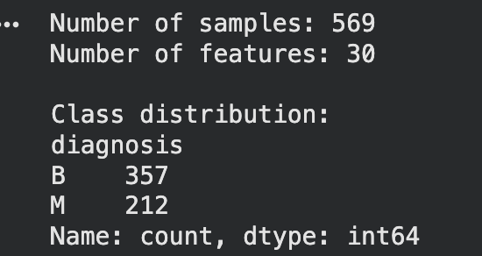

- We converted features to numbers and handled the missing values.
- Next we divided our dataset 80/20 into training and testing data. 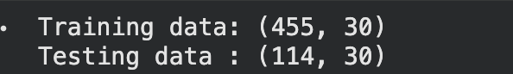

- We standardised our features,wrote our distance functions and converted data to binary which would be req for calculating hamming distance.
- We implemented our KNN function from scratch and initialised an accuracy function
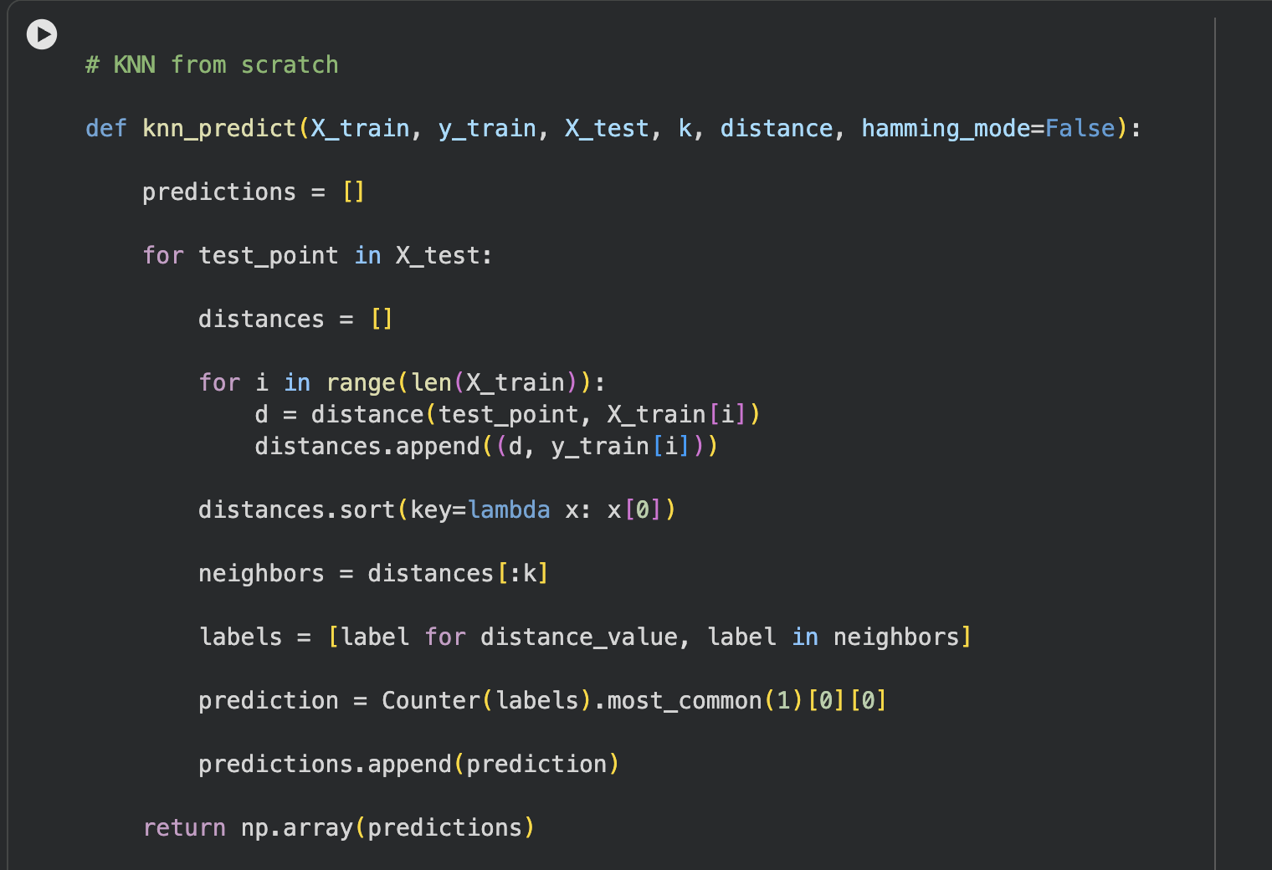

- We experimented with different distance functions and K values and found that:
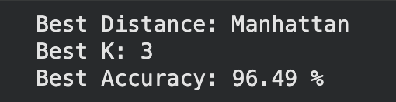
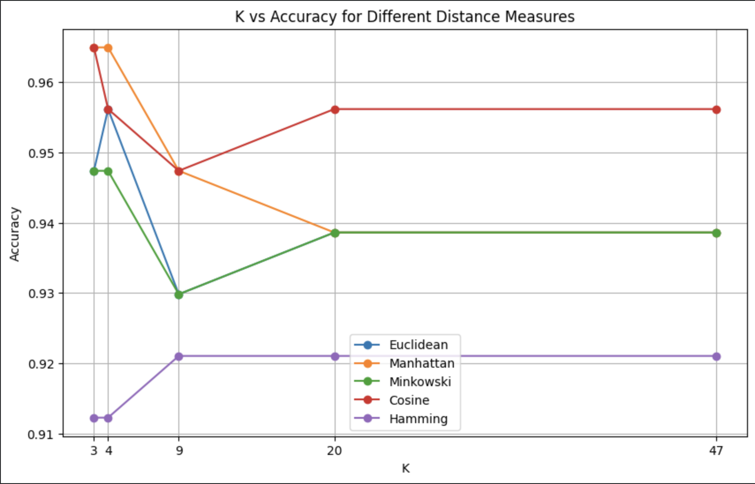

- Next we implemented our confusion matrix and calculated the precision and recall
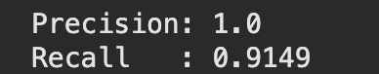
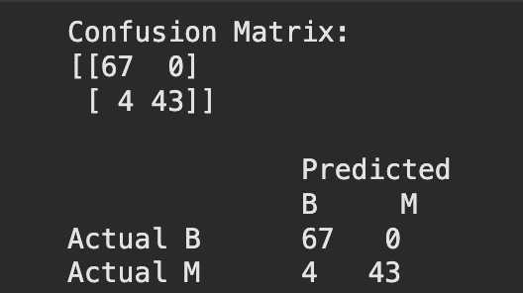

- For the bonus question we visualized the decision boundary for the best KNN model according to our results.

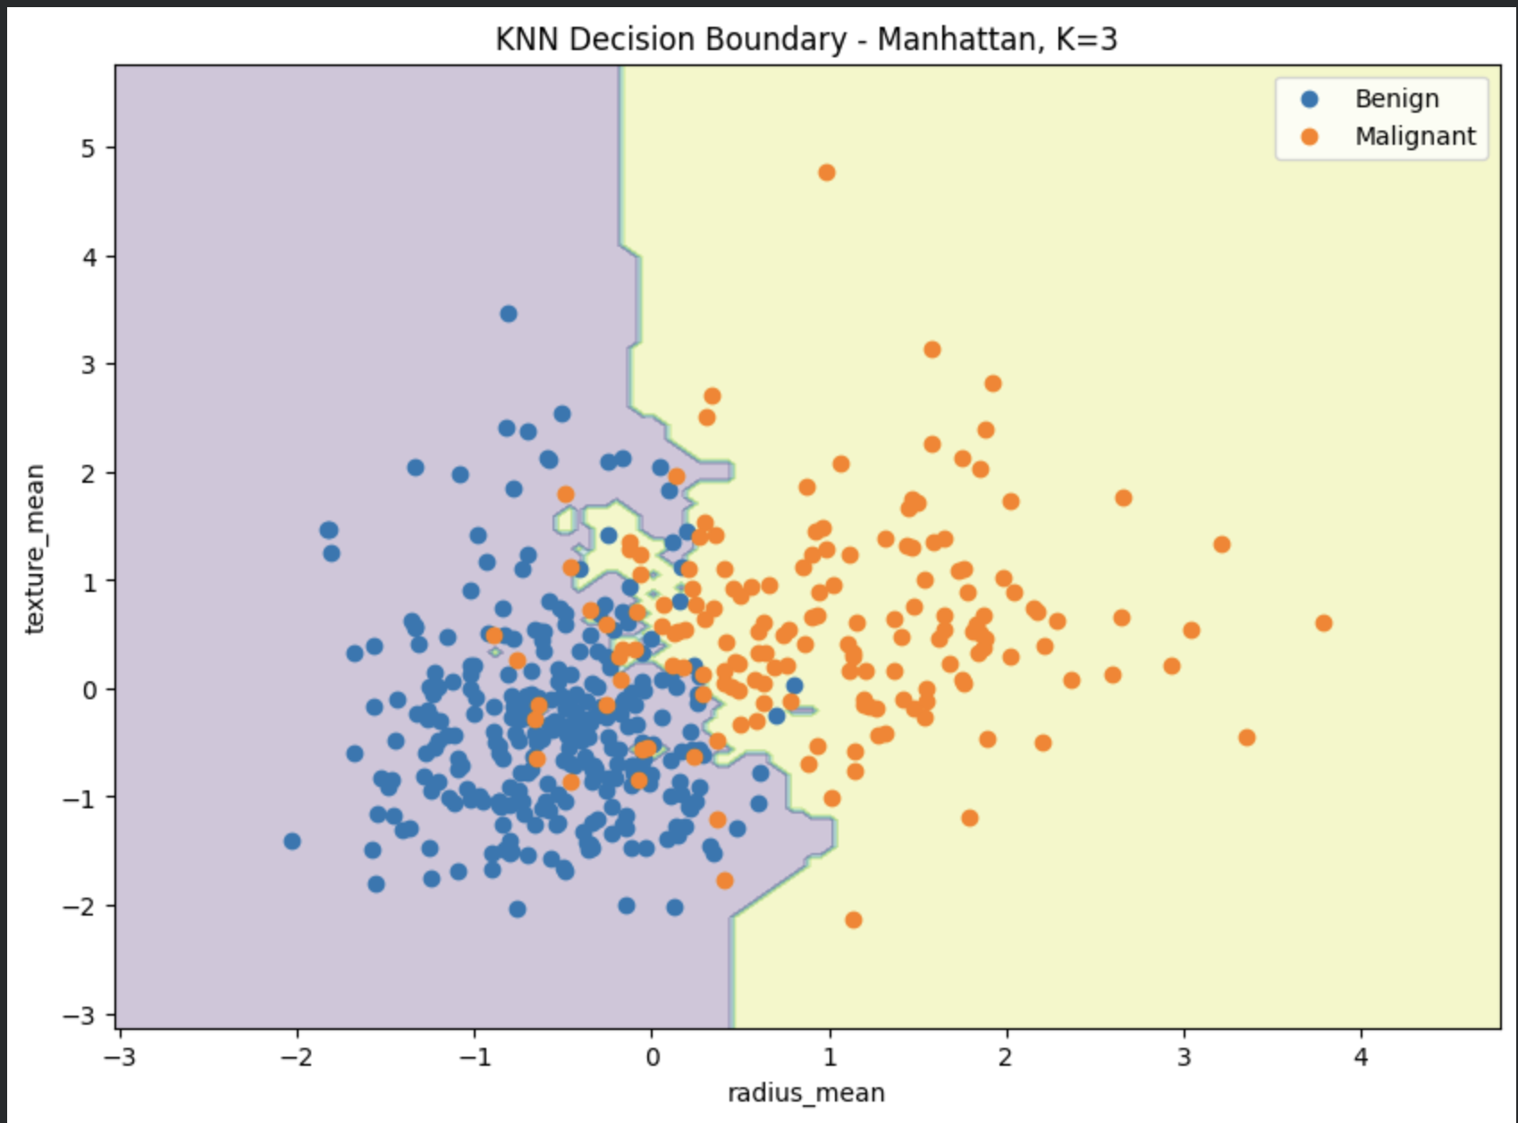

For the second task we were given the CIFAR-10 dataset which is a collection of 60,000 32x32 color images in 10 classes, with 6,000 images per class. The dataset is split into 50,000 training images and 10,000 test images. We had to build a KNN based classification model from scratch to classify these images into one of the 10 classes.

These were the Expected Outcomes:
● Build a KNN-based classification model from scratch to classify images in the
CIFAR-10 dataset.
● Experiment with different values of K (number of neighbors) and various distance
metrics, including Euclidean Distance, Manhattan Distance, Minkowski Distance,
Cosine Similarity, and Hamming Distance.
● Pick the best value of K and distance matrix based on the testing accuracy, and
for the best value of K, print confusion matrix, recall, and precision.
● Visualize the impact of different distance metrics on the accuracy across varying
values of K.
● Insights and inferences based on the experimental results and plots.

Brief Overview of the Procedure

- We first uploaded our dataset and imported the necessary libraries needed to work with our data
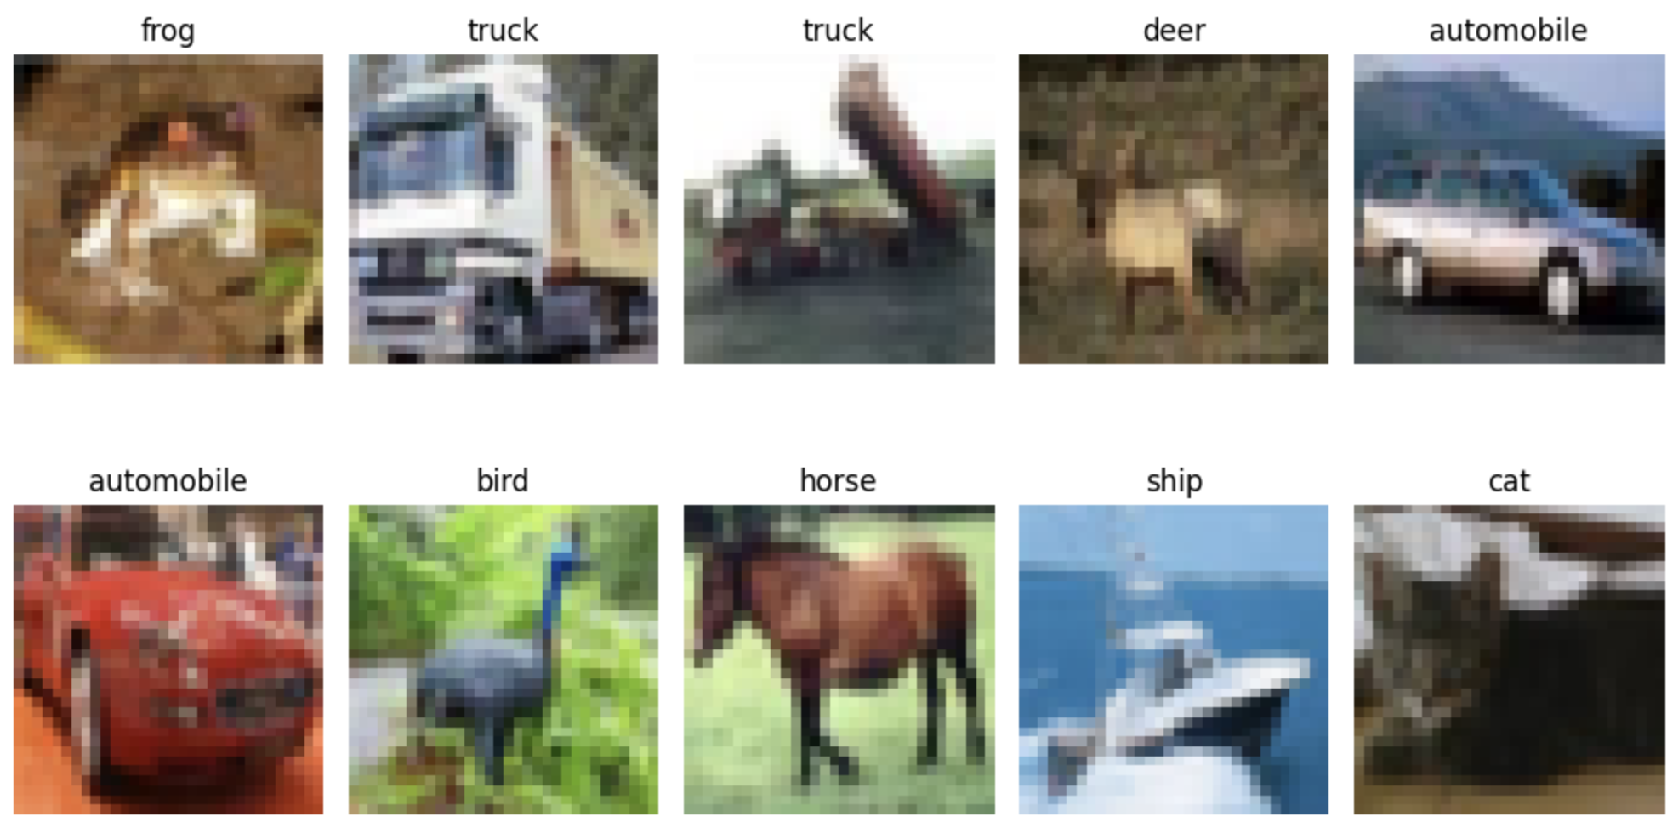
- We preprocessed our data and observed our training and testing sample size.
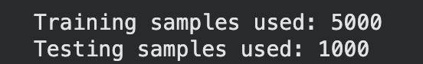

- We initialized our distance functions and implemented our KNN function
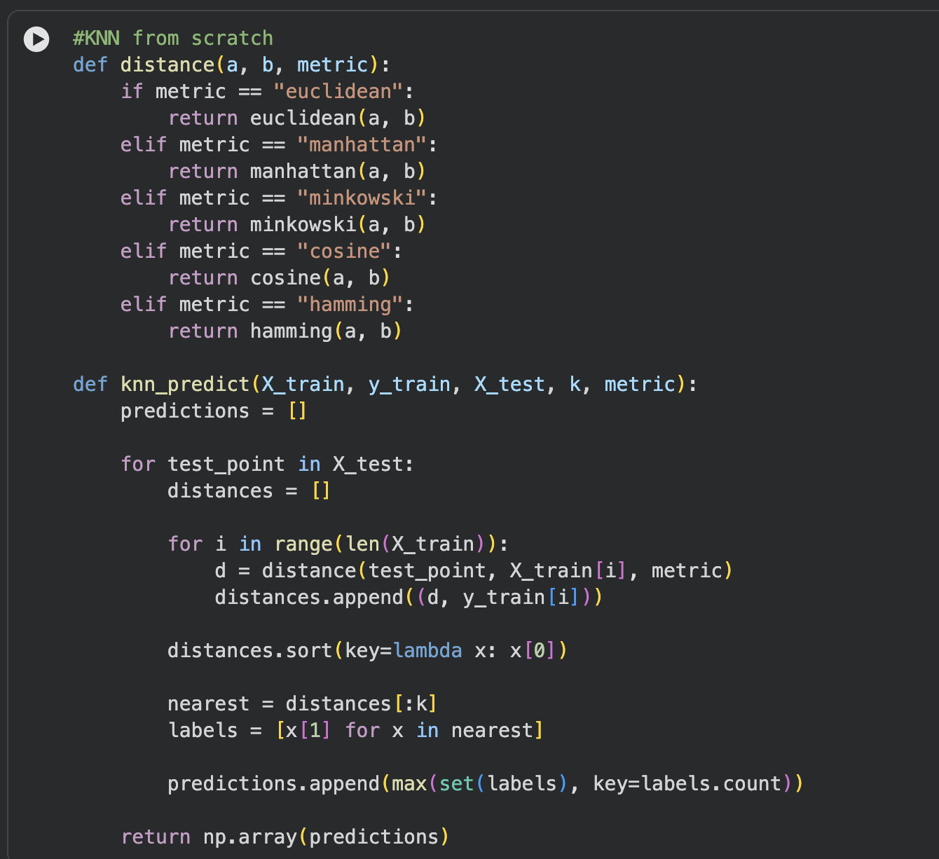

- We found our best hyperparameters 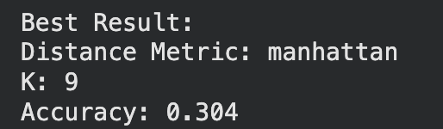

- We visualize the accuracy of our hyperparameters to better observe them
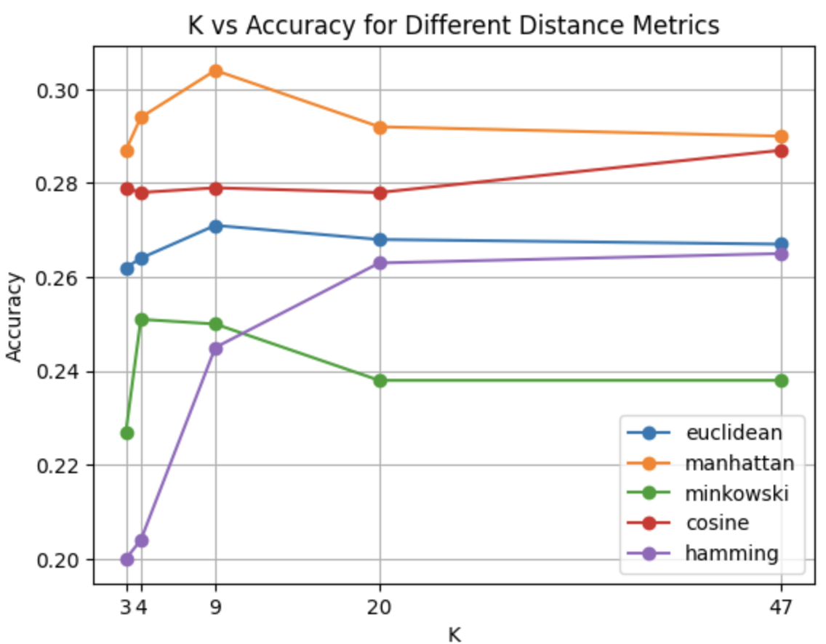
- We observe the confusion matrix and calculate the recall and precision values. 